**Assignment 7 : Group B (Unit III & IV)**

|  |  |  |  |  |  |  |
| --- | --- | --- | --- | --- | --- | --- |
| **W (4)** | **C (4)** | **D (4)** | **V(4)** | **T (4)** | **Total** | **Sign** |
|  |  |  |  |  |  |  |

**Date of Performance ____________**

**Date of Completion** :_____________

**Problem Definition:**

**PROBLEM STATEMENT:**

**Write a program to implement link state /Distance vector routing protocol to find suitable path for transmission**

**7.1 Prerequisite:**

1.Shortest path finding

2. Classification of routing Algorithm

**7.2 LearningObjectives**:

1. Understand the concept Distance vector routing

2. Understand the Concept of Routing Algorithms

**7.3 Theory**

A distance-vector routing (DVR) protocol requires that a router inform its neighbors of topology changes periodically. Historically known as the old ARPANET routing algorithm (or known as Bellman-Ford algorithm).

Bellman Ford Basics – Each router maintains a Distance Vector table containing the distance between itself and ALL possible destination nodes. Distances,based on a chosen metric, are computed using information from the neighbors’ distance vectors.

Information kept by DV router -

* Each router has an ID

Associated with each link connected to a router,

* there is a link cost (static or dynamic).
* Intermediate hops

Distance Vector Table Initialization -

* Distance to itself = 0
* Distance to ALL other routers = infinity number.

**Distance Vector Algorithm –**

1. A router transmits its distance vector to each of its neighbors in a routing packet.
2. Each router receives and saves the most recently received distance vector from each of its neighbors.
3. A router recalculates its distance vector when:
   * It receives a distance vector from a neighbor containing different information than before.
   * It discovers that a link to a neighbor has gone down.

The DV calculation is based on minimizing the cost to each destination

Dx(y) = Estimate of least cost from x to y

C(x,v) = Node x knows cost to each neighbor v

Dx = [Dx(y): y ∈ N ] = Node x maintains distance vector

Node x also maintains its neighbors' distance vectors

– For each neighbor v, x maintains Dv = [Dv(y): y ∈ N ]

**7.4.1 Introduction**

Distance Vector Routing –

* It is a dynamic routing algorithm in which each router computes distance between itself and each possible destination i.e. its immediate neighbors.
* The router share its knowledge about the whole network to its neighbors and accordingly updates table based on its neighbors.
* The sharing of information with the neighbors takes place at regular intervals.
* It makes use of Bellman Ford Algorithm for making routing tables.
* Problems – Count to infinity problem which can be solved by splitting horizon.  
  – Good news spread fast and bad news spread slowly.  
  – Persistent looping problem i.e. loop will be there forever.

[Link State Routing](https://practice.geeksforgeeks.org/problems/what-is-link-state-routing-protocol) –

* It is a dynamic routing algorithm in which each router shares knowledge of its neighbors with every other router in the network.
* A router sends its information about its neighbors only to all the routers through flooding.
* Information sharing takes place only whenever there is a change.
* It makes use of Dijkastra’s Algorithm for making routing tables.
* Problems – Heavy traffic due to flooding of packets.  
  – Flooding can result in infinite looping which can be solved by using Time to live (TTL) field.

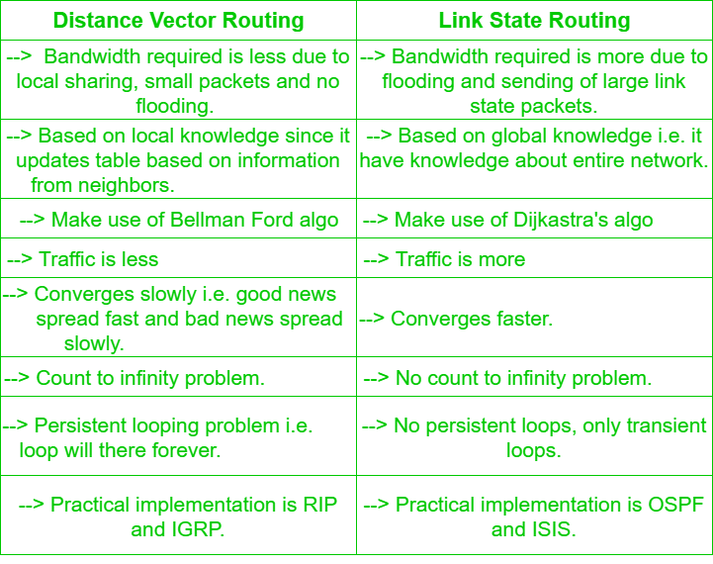

**AssignmentQuestions:**

1.What is Dynamic and static routing ?

2. What is DVR ?.

3. What is drawback of DVR?

4.How is DVR different from LSR ?

**Conclusion:** Hence we have studied distance vector algorithm to find suitable path for transmission